**SRAJAN KOTIAN**

**KCTYBSCIT 026**

**DEVOPS**

**PRACTICAL NO 1**

**INSTALLATION OF GIT**

**SIGN:**

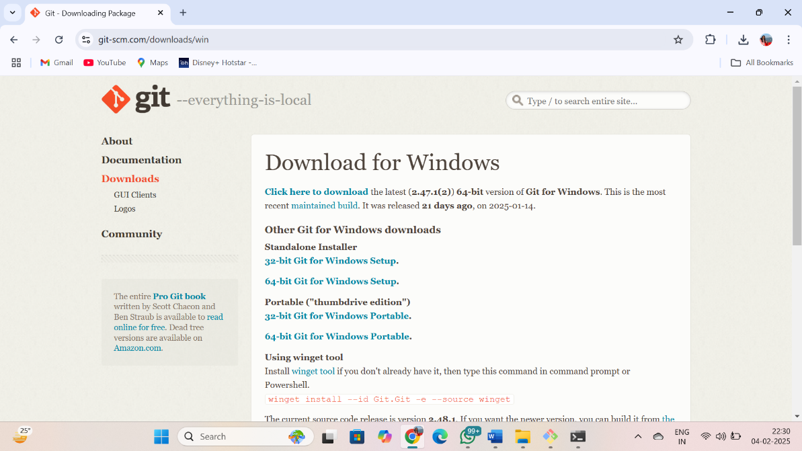

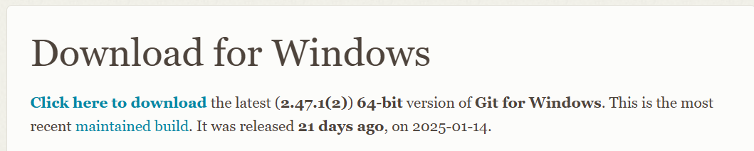

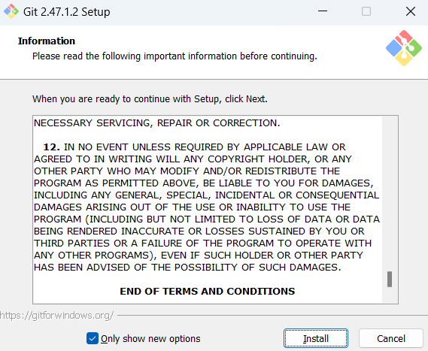

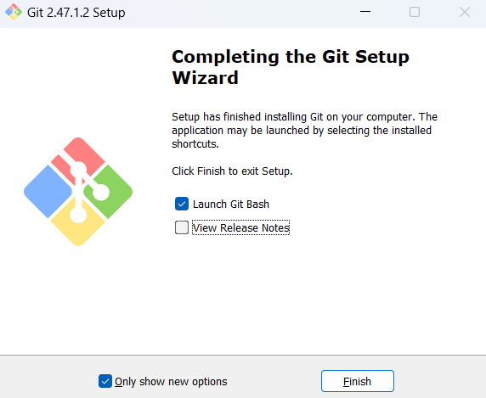

**SRAJAN KOTIAN**

**KCTYBSCIT 026**

**DEVOPS**

**PRACTICAL NO 2**

**SIGN:**

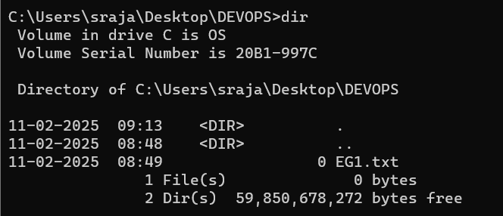





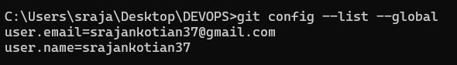







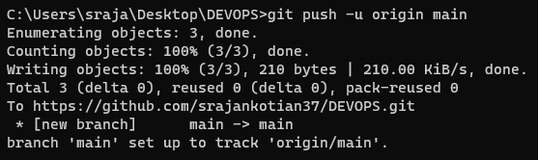

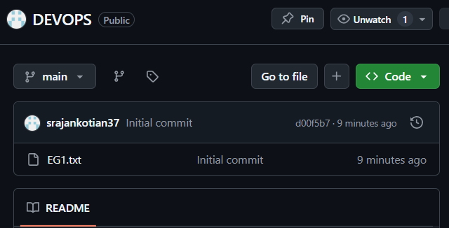

**SRAJAN KOTIAN**

**KCTYBSCIT 026**

**DEVOPS**

**PRACTICAL NO 3**

**SIGN:**

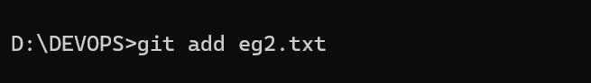

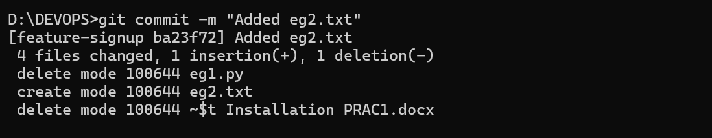

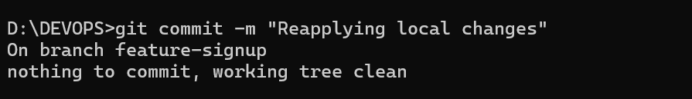

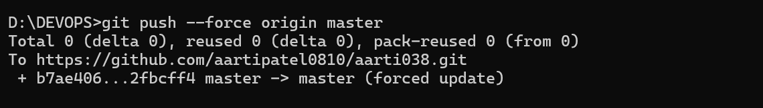

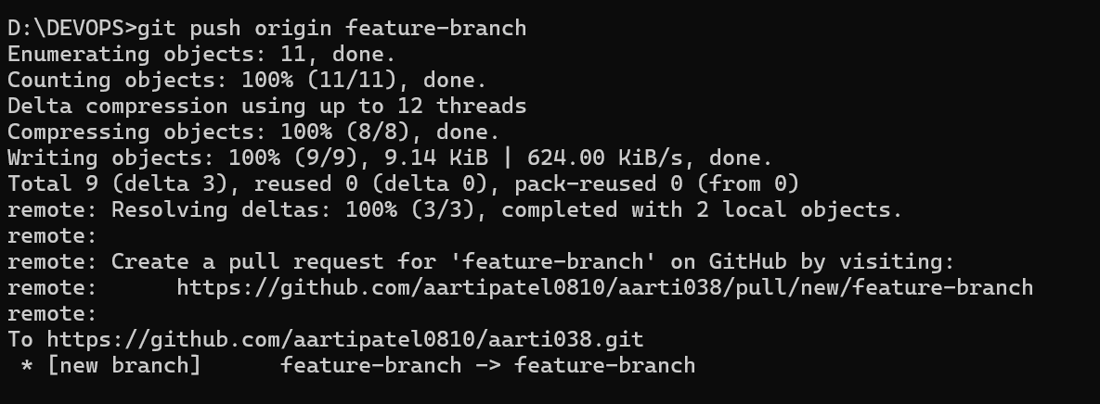

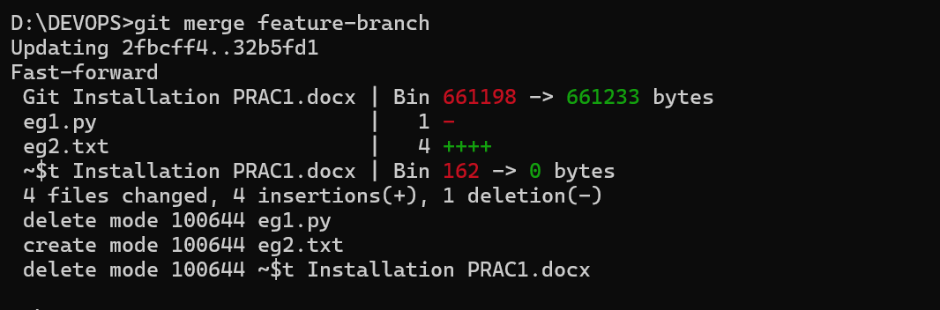

**SRAJAN KOTIAN**

**KCTYBSCIT 026**

**DEVOPS**

**PRACTICAL NO 4**

**SIGN:**

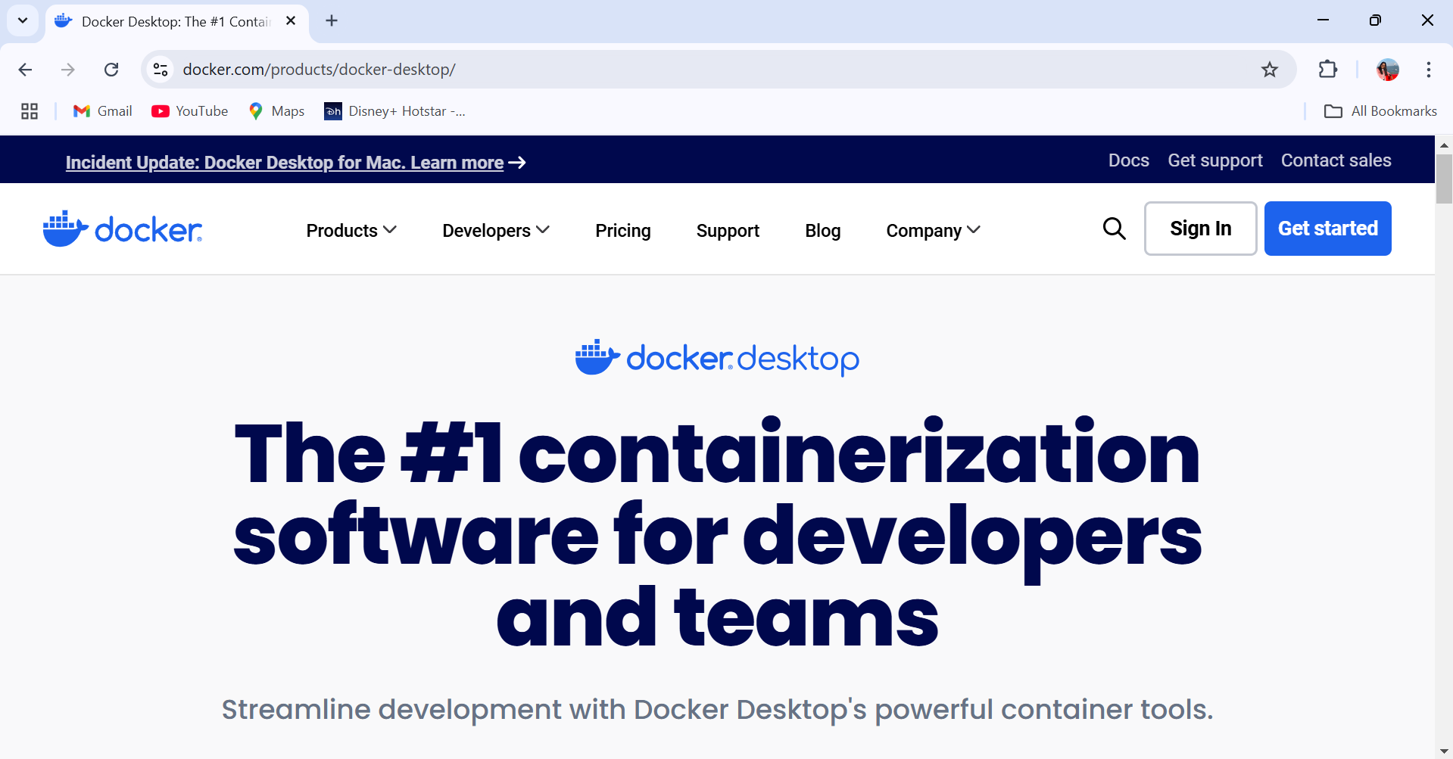

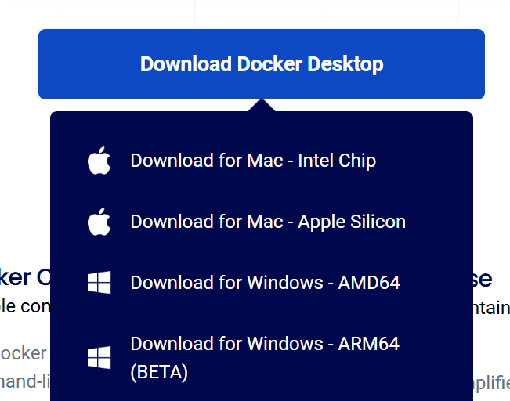

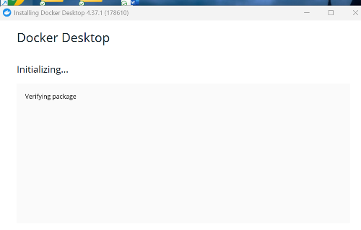

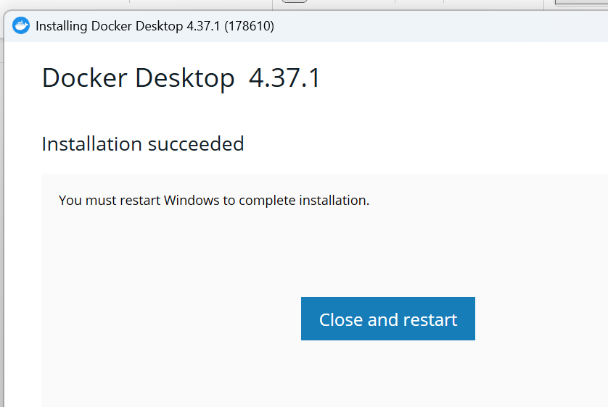

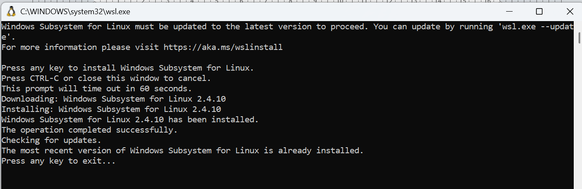

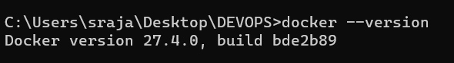

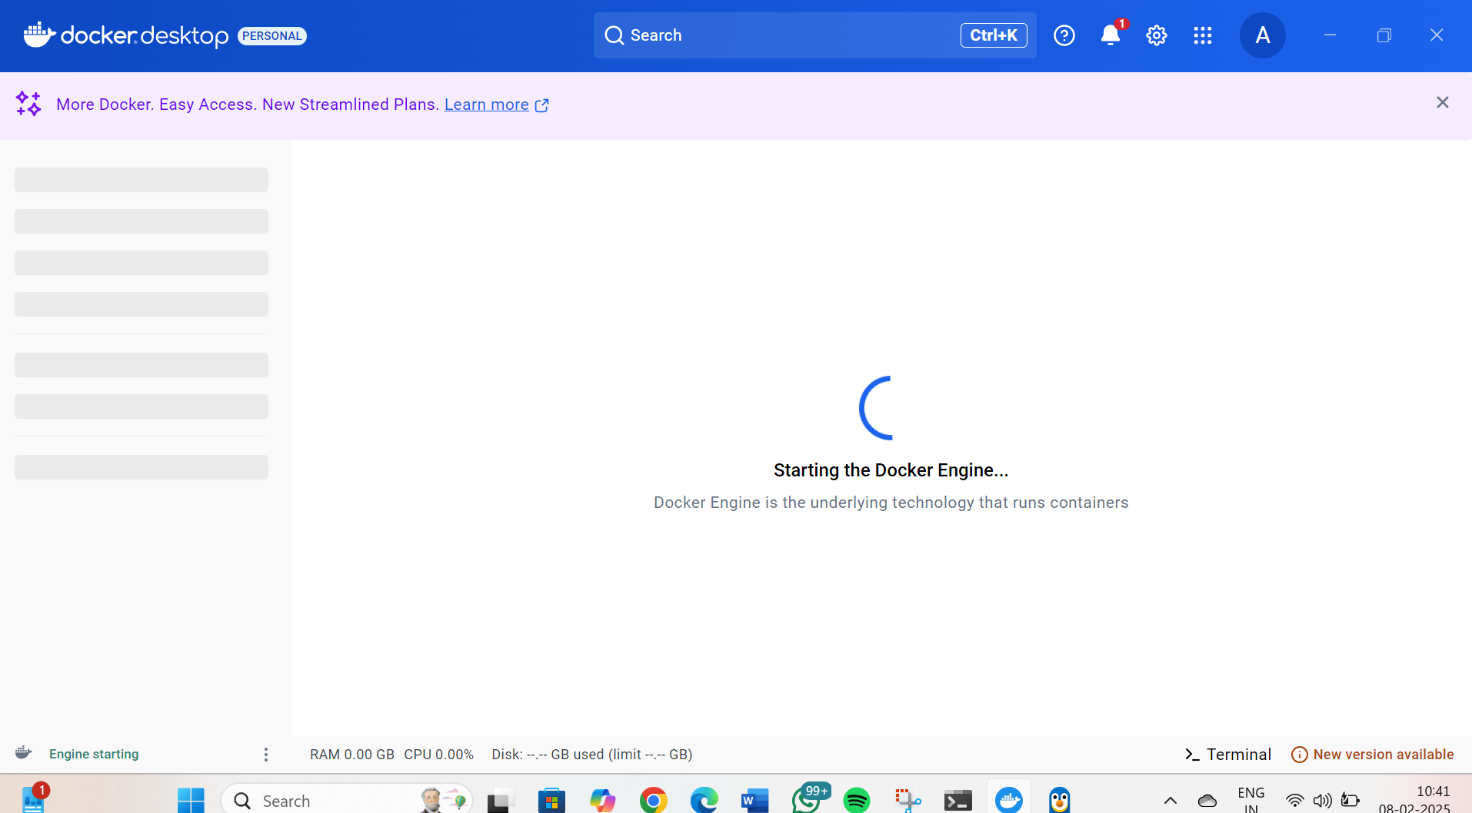

**SRAJAN KOTIAN**

**KCTYBSCIT 026**

**DEVOPS**

**PRACTICAL NO 5**

**SIGN:**

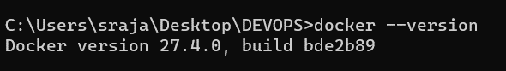

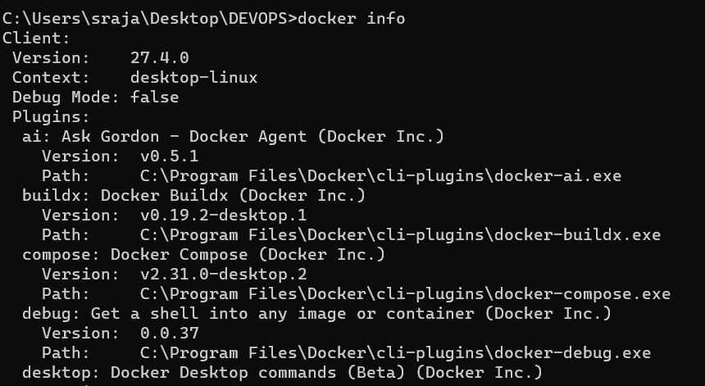

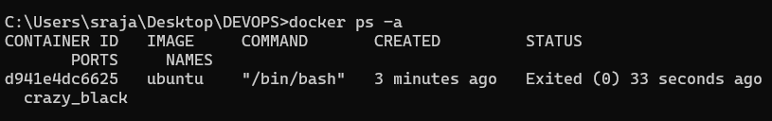





**SRAJAN KOTIAN**

**KCTYBSCIT 026**

**DEVOPS**

**PRACTICAL NO 6**

**SIGN:**

Working with python in Docker

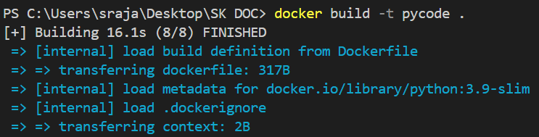

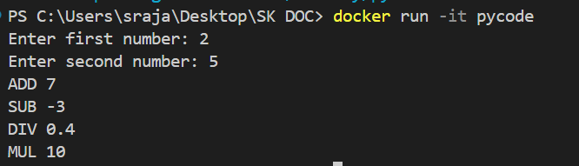

**SRAJAN KOTIAN**

**KCTYBSCIT 026**

**DEVOPS**

**PRACTICAL NO 7**

**SIGN:**

Working with java in Docker

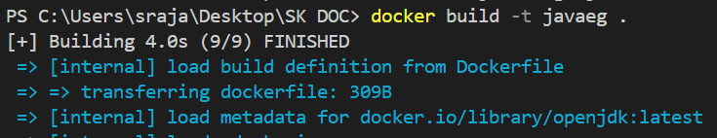

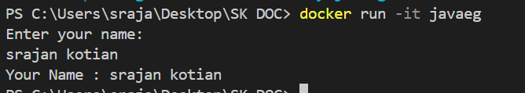

**SRAJAN KOTIAN**

**KCTYBSCIT 026**

**DEVOPS**

**PRACTICAL NO 8**

**SIGN:**

Working with node js in Docker

Dockerfile

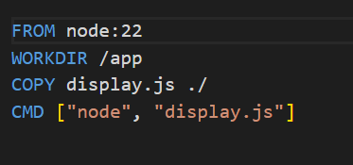

Output:

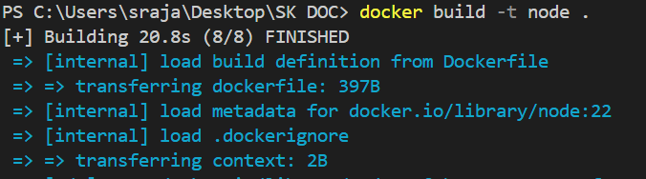



**SRAJAN KOTIAN**

**KCTYBSCIT 026**

**DEVOPS**

**PRACTICAL NO 9**

**SIGN:**

Dockerfile

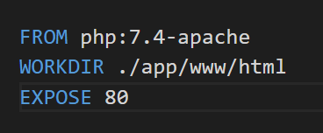

Output:

